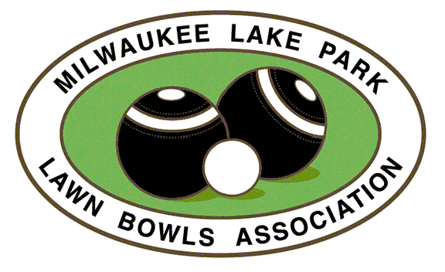 | Guest Registration

Date:

Event: □ Open House □ Lesson □ Group Event □

Name:

Phone:

Email :

How did you hear about us?

□ Internet search
□ Facebook
□ Fence brochure
□ Clubhouse bulletin board
□ Yard sign
□ Lake Park Friends
□ Milwaukee County Parks
□ Lake Park Bistro
□ JSOnline.com
□ OnMilwaukee.com
□ Bowls USA/Central Division
□ Club Member:
□ Other:

Are you a member of another lawn bowls club?
□ No □ Yes,

Are you interested to learn about club membership?
□ No □ Yes,

CLUB USE ONLY

Payment amount:

Payment method: cash check Paypal/Website

