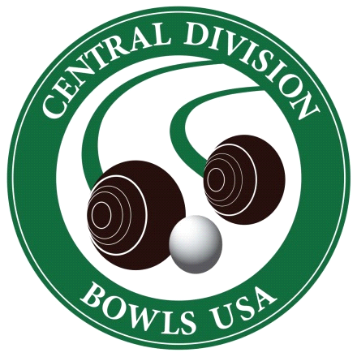Central Division
Open Tournament

Pairs Tournament: August 8, 2020

Start time: 8:00 a.m.
Entry fee: $60 per team/$30 per individual
Entry deadline: August 2, 2020

This event is open, meaning any combination of men and women teams may enter, and is played over two days. Members of the Bowls USA and World Bowls organizations are welcome to participate.

Singles Tournament: August 9, 2020

Start time: 8:00 a.m. both days
Entry fee: $30 per individual
Entry deadline: August 2, 2020

This event is mixed, meaning men and women may compete against each other, and is played over two days. Members of the Bowls USA and World Bowls organizations are welcome to participate.

Official Entry Form

Name: Click or tap here to enter text.
Address: Click or tap here to enter text.
Phone: Click or tap here to enter text.
Email: Click or tap here to enter text.
Bowls Club: Click or tap here to enter text.

☐ Singles
☐ Pairs - Partners Name: Click or tap here to enter text.

Amount submitted: Click or tap here to enter text. (checks payable to “Central Division USLBA”)
(Venmo: @Rebecca-Nguyen-99)

Provide form and fees to… Rebecca Nguyen
1522 N Prospect Ave, Unit 504
Milwaukee, WI 53202

rebeccalnguyen@yahoo.com
414-202-4590

